Submarine CLASsES

Beware of the silence

Stealthy, agile and armed with some of the most powerful weapons on the planet, Navy submarines and their crews play a number of roles in both war and peace time: attack, surveillance, commando insertion, research and nuclear deterrence. Submarine operators are known as the “Silent Service,” where standards are incredibly high and victories are often kept secret.

Navy submarines are some of the most high-tech vessels in the world. They can insert SEAL teams into hostile target areas, launch ballistic missiles, take out enemy subs and ships, perform reconnaissance and rescue missions, and also serve as a platform for nuclear weapons.

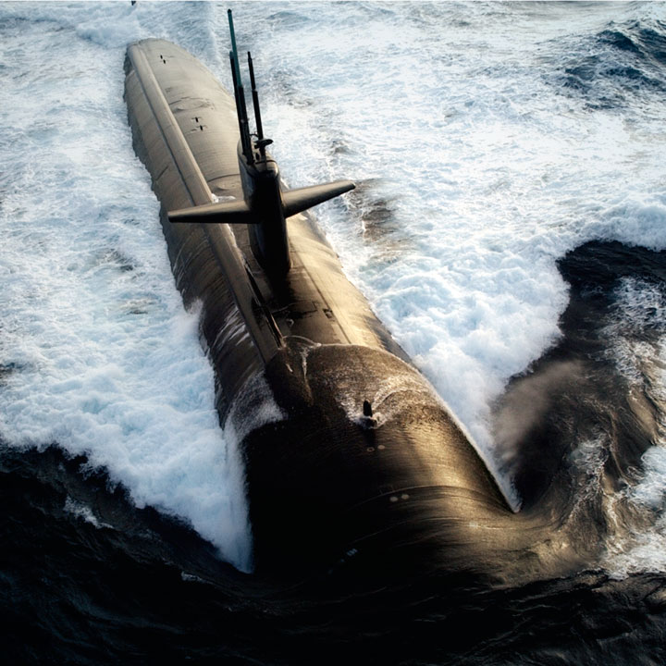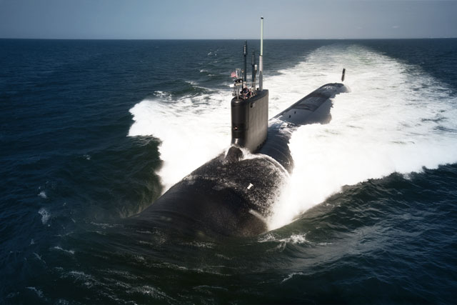

Attack Submarines (SSNs)

Hunters Beneath

The Navy deploys three classes of these sleek subs: the Los Angeles, Seawolf and Virginia. All are capable of performing seek-and-destroy missions on enemy ships and subs, surveillance and reconnaissance, irregular warfare, covert troop insertion, mine and anti-mine operations and more. Plus, each is armed with Tomahawk® cruise missiles to stealthily strike targets from far out.

Get the specs and tech of the all three [**attack submarine classes**](http://www.navy.mil/navydata/fact_display.asp?cid=4100&tid=100&ct=4%20).

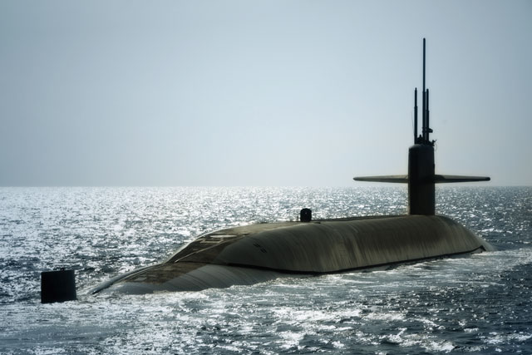

Ballistic Missile Submarines (SSBN)

The Backbone of Strategic Deterrence

"Boomers" may have the most important mission in the Navy: strategic nuclear deterrence. They were built for it as their sole role. Capable of operating underwater for months on end, Ballistic Missile Submarines require crews that can work together under any circumstance. They can defend themselves individually with torpedoes, but what they do for the defense of America cannot be measured.

Get the specs and tech of the [**Ohio-Class Ballistic Missile Submarine**](http://www.navy.mil/navydata/fact_display.asp?cid=4100&tid=200&ct=4%20).

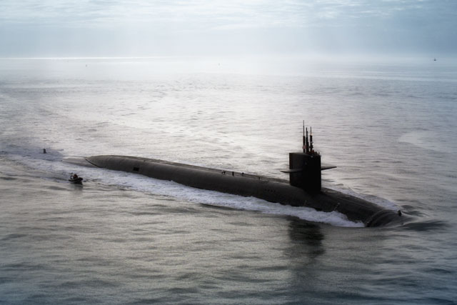

Guided Missile Submarines (SSGN)

Precision From Beneath

To complement the potent guided-missile platform of Cruisers and Destroyers, the Navy needed something a little more stealthy. And few things are as stealthy as an Ohio-Class boomer. Guided Missile Submarines were converted from that class and can carry over 150 Tomahawk® missiles plus transport and support Navy Special Operations forces.

Get the specs and tech of [**Guided Missile Submarines**](http://www.navy.mil/navydata/fact_display.asp?cid=4100&tid=300&ct=4%20).

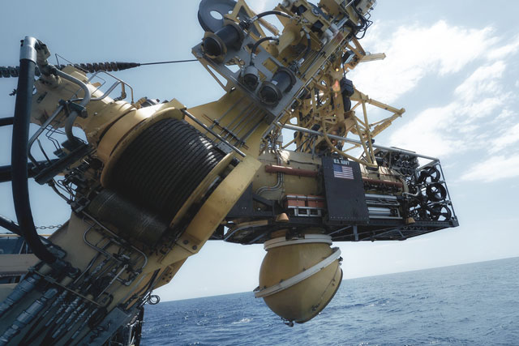

Deep Submergence Rescue Vehicles (DSRVs)

The Sub Fleet's Life Vest

When trouble happens beneath the waves, there is only one vessel to call on: the DSRV. They perform underwater rescue operations on disabled submarines for the US or foreign navies. They’re designed for quick deployment in the event of a submarine accident – transportable by truck, aircraft, ship or specially configured attack submarine. Many Sailors owe their lives to the capabilities of a DSRV and its crew.

Get the specs and tech of [**Deep Submergence Rescue Vehicles**](http://www.navy.mil/navydata/fact_display.asp?cid=4100&tid=500&ct=4).